

Department of Electrical and Electronic Engineering

MEC104(S2) Experimental, Computer Skills and Sustainability

Lab 2 Smart Car

Group number：A26

Group members：
Tiankuo.Jiao 1929098
Yuahng.Jiang 1927888
Zhuoyuan.Liu 1927020
Submission date:04/30/2021

Abstract

In this experiment, we used TinkerCAD to simulate the car. Firstly, we realized five essential operations, which include fast forward, slow forward, fast reverse, slow reverse, braking by controlling two motors. Subsequently, we successfully controlled these functions by applying infrared remote (IR) control. Ultimately, we used an ultrasonic distance sensor as an obstacle avoidance device. When the distance is within [50-100] cm, the car slows down; when the distance is within [0-50] cm, the car brakes.
As to hardware, we utilized simulated devices in the experiment, including L239D, infrared remote control, ultrasonic distance sensor. In the discussion part, we also analyzed errors of these devices.
As to software, we defined several different functions to control different motion states of the motors, and called the functions in the loop to change the state each time a cycle is entered. The state to be changed depended on whether the infrared signal or the ultrasonic sensor signal is read at the beginning of each cycle.
Ultimately, we fulfilled various requirements and analyzed errors of the experiment.

Catalogue

Abstract 2
1.Introduction 4
1.1 Brief Introduction to the Experiment 4
1.2 The experiment purpose 4
2.Experimental procedure 4
2.1 Theory 4
2.1.1 The theory of DC motors 4
2.1.2 The theory of H-Bridge 5
2.1.3 The theory of IR remote control 6
2.1.4 The theory of ultrasonic distance sensor 6
2.2 Circuit Design 6
2.3 Experimental method 7
2.3.1. The experimental apparatus 7
2.3.2 The experimental principle 7
2.3.3 The ultrasonic sensor principle 7
2.3.4 Control the driver motors 7
2.3.5 Switch the motion state of Smart car 8
2.4 Coding flowchart 8
2.5 Results about the different functions of the car 9
3.Discussion about the experiment 10
3.1 The experiment error 10
3.1.1 Analysis of infrared remote control error 10
3.1.2 Error analysis of ultrasonic distance sensor 11
3.2 Discussion of results 12
4.Conclusion 12
4.1 The hardware part 12
4.1.1 The H-bridge L239D 12
4.1.2 Infrared remote control 12
4.1.3 Ultrasonic distance sensor 12
4.2 Software part 13
4.2.1 Infrared sensor part 14
4.2.2 Ultrasonic distance sensor 14
5.Author list and contributions 14
6.Appendix 14

- Introduction

1.1 Brief Introduction to the Experiment
In this experiment, we are asked to make a smart car by using Arduino Uno. This experiment covers what we learned before, including setting up pins, set the output level of each pin to control the peripheral circuit. It also covers something new, such as the operation principle of the motor, the working principle of an ultrasonic distance sensor, and how to connect the circuit including all equipment. Arduino Uno is a very important integrated circuit board, which is not only novice-friendly but also multifunctional. Moreover, DC motors and ultrasonic distance sensors are being applied to multiple areas in our daily lives. So, it is necessary for everyone to have some basic knowledge about them.

1.2 The experiment purpose
The purpose of this experiment is to control a driving DC motor by applying Arduino Uno. We want to achieve five essential functions: fast forward motion, slow forward motion, fast reverse motion, slow reverse motion and break. Then we will try to use an IR remote control to switch between these four functions. As long as we press the bottom, the corresponding function should be applied to the motor. We can measure this by watching the spin speed appear on the motor when the simulation starts in Tinker CAD. We also want to apply an ultrasonic distance sensor to make a safety device for the car. If any object is getting closer to the car, the motor should first slow down and then break. Simultaneously, a LED warning light should be lighted up when the motor’s spin velocity is decreasing. We can monitor this function by watching whether the motor’s spin velocity decreases when the LED is lighted up.

2.Experimental procedure

2.1 Theory

2.1.1 The theory of DC motors
In this experiment, we used a DC motor. Since the DC motors generally require more current than Arduino’s built-in power supply can provide. Also, motors can create harmful voltage spikes due to their inductive nature. To deal with this problem, we have to isolate the DC motor from Arduino. Thus, we should use a well designed 9V battery to power the motor. The battery should be hooked up correctly so that electronics can be safe in the circuit. The general circuit to control the motor is as follows:
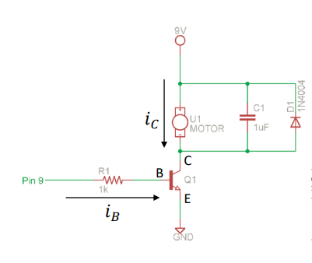

Figure 1: DC motor control circuit
The NPN type bipolar-junction transistor is used to separate the 9V supply to the motor. If there is a reverse voltage, the diode can protect the motor. As we learned last term, we know that if we apply enough voltage on the base terminal of NPN BJT, the current can flow through the transistor, and the motor would start spinning. If we want to control the spinning speed of the motor, we have to use the PWM pins on Arduino to rapidly apply different voltage on the base terminal of the transistor to turn the transistor on and off.

2.1.2 The theory of H-Bridge
The motor can only rotate forward if we connect the circuit above. So, to make the motor rotate both forward and backwards, we have to apply an H-bridge of type L239D. It looks like this:

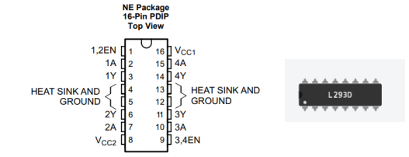

Figure 2: L239D type H-bridge [1]

We can connect the H-bridge to the motor and control the state of the four switches inside to control the current direction within the motor so that the motor can rotate in both directions or break. The switch state to control motor to do forward motion, back word motion, and the brake is as follows:

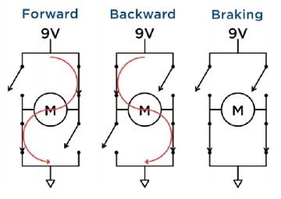

Figure 3: Switch states to control rotate direction [1]

2.1.3 The theory of IR remote control
To use an IR remote to control the motor, we need an IR signal receiver in the circuit to convert IR light into an electrical signal first. Generally, it is a diode. In Arduino projects, the NEC protocol is most commonly applied to convert the IR signal to binary. So we can use include IRremote library and use the corresponding programme to receive the signal. When bottoms on the remote are pressed, we will receive a 0XFFFFFFFF type code. In the programme, we can identify the protocol used by the remote and convert the signal to control the motor.

2.1.4 The theory of ultrasonic distance sensor
We also used an ultrasonic distance sensor to detect closing objects. This device uses ultrasonic to measure the distance between the device and the closed object. Send out a sound wave, receive the sound wave when it comes back, calculate the time used for the travel, and use a specific algorithm to calculate the distance.

2.2 Circuit Design
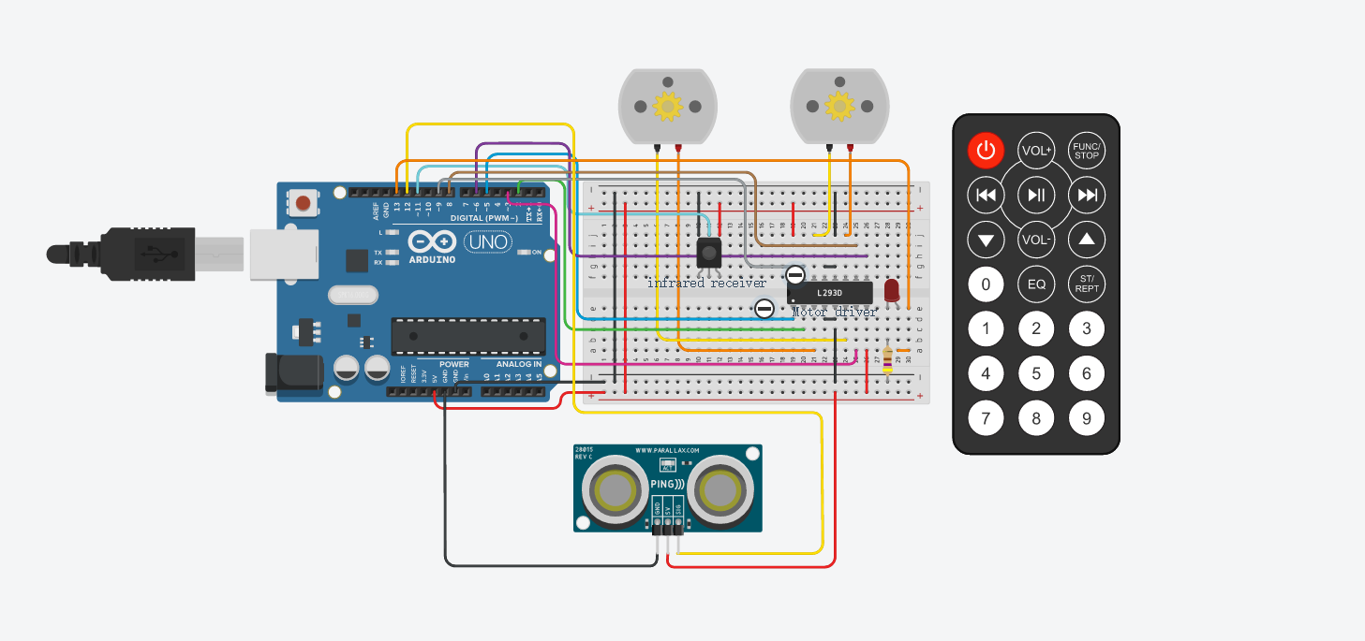
Figure 4:Simulation diagram of the experiment

2.3 Experimental method
2.3.1. The experimental apparatus
The experiment was conducted under simulation by the TinkerCAD software. The equipment exploited included a breadboard, two DC motors, an Arduino UNO R3 board, an H-bridge motor driver, an infrared receiver, a 470Ω resistor, a LED, remote control and an ultrasonic sensor, plus several wires. Moreover, a specific experimental circuit diagram has shown in the circuit design above.

2.3.2 The experimental principle
The principle of the L293D driver controlling the rotation of motors has been introduced before. The infrared receiver will generate a corresponding PWM signal when receiving an infrared pulse from the remote control and transmit the signal to the MPU through PWM Pin11. The library ‘IRremote.h’ worked on decoding the infrared signal and used hexadecimal addresses to represent different buttons’ signals.

2.3.3 The ultrasonic sensor principle
The ultrasonic sensor has a Pin named ‘SIG’, which represents the signal Pin, and whose role is both ‘echo’ Pin and ‘trig’ Pin. In a signal detection cycle, the ‘SIG’ Pin is firstly set to high voltage output mode to send an ultrasonic wave and then immediately set to input mode to read the reflected wave so that the time period of the wave travelling can be detected. Thus the distance to the object (in the unit of cm) can be calculated by:
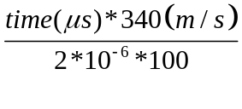 [1]
The 'SIG' Pin was connected to Pin 12 of the UNO board. The LED has the function of indicating that the ultrasonic sensor has detected an object within 100cm away and that the motors have to slow down or have to brake when the distance is under 50cm. This function is realized by connecting the LED's anode to the Pin 13, whose voltage can be decided.

2.3.4 Control the driver motors
The UNO board is connected to the driver by three Pins which are IN1, IN2 and PWM for each motor. The former two Pins control the direction while the last is for speed. The driver is then connected to each motor with two wires, with current magnitude controlling the speed and current direction controlling the direction. The rotation state is then simply set by numeric expression with magnitude and +/- signs in the code.

2.3.5 Switch the motion state of Smart car
Since the operation is simple, there is no need for interruption. As the Arduino's coding structure already includes a loop 'void loop{}', the method of switching the states each time an infrared command is given or the distance is changed is simply by using a switch-case logic for the remote control part and an 'if' logic for the distance judging part, both under the 'void loop{}' function. Hence, in each cycle, the state can change.
See appendix for more details.
2.4 Coding flowchart
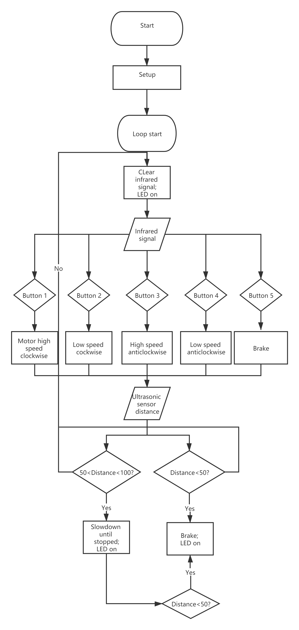
Figure 5: Coding structure
2.5 Results about the different functions of the car
The simulated circuit operated as expectation, with a portion of the status presented as the following screenshots:

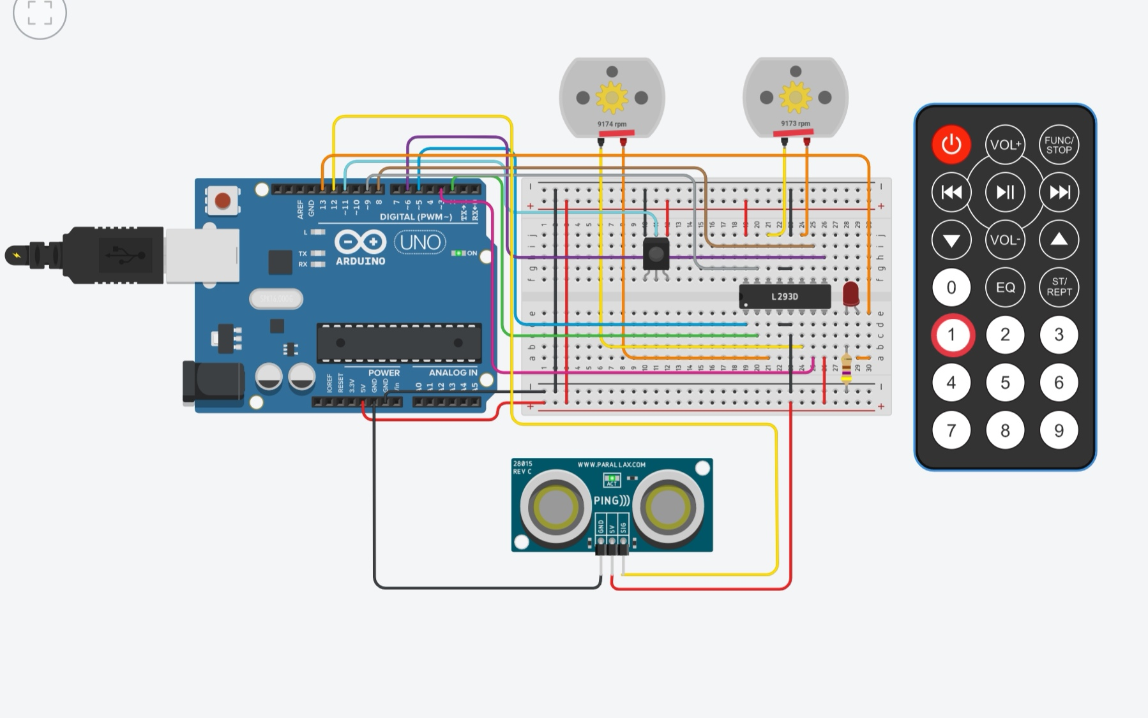
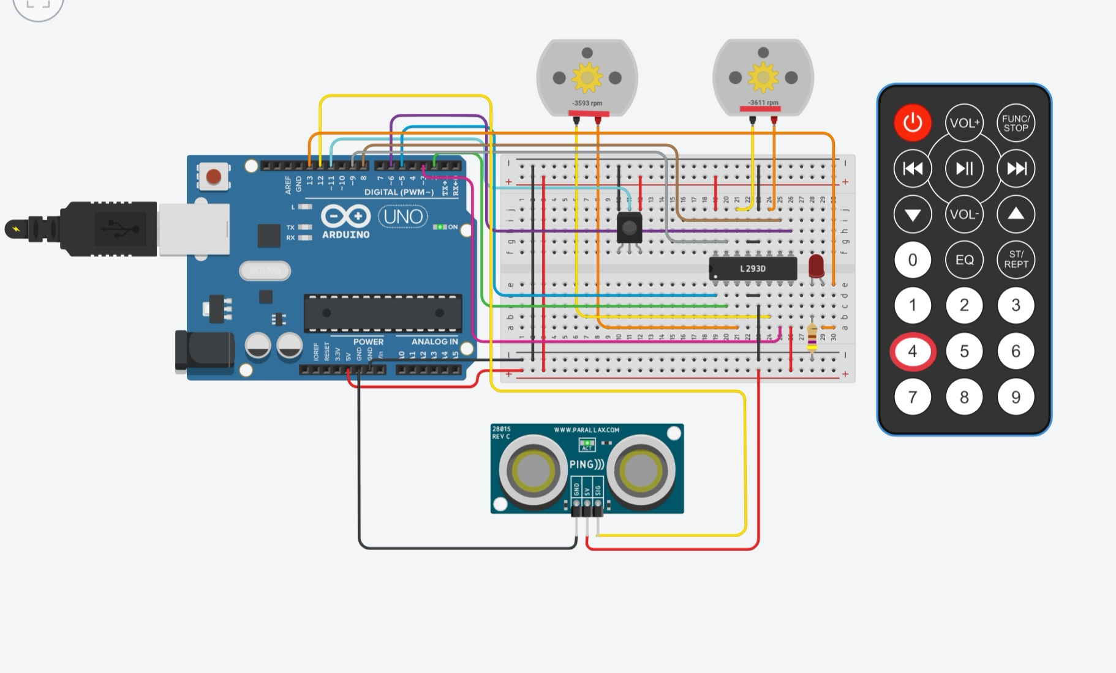
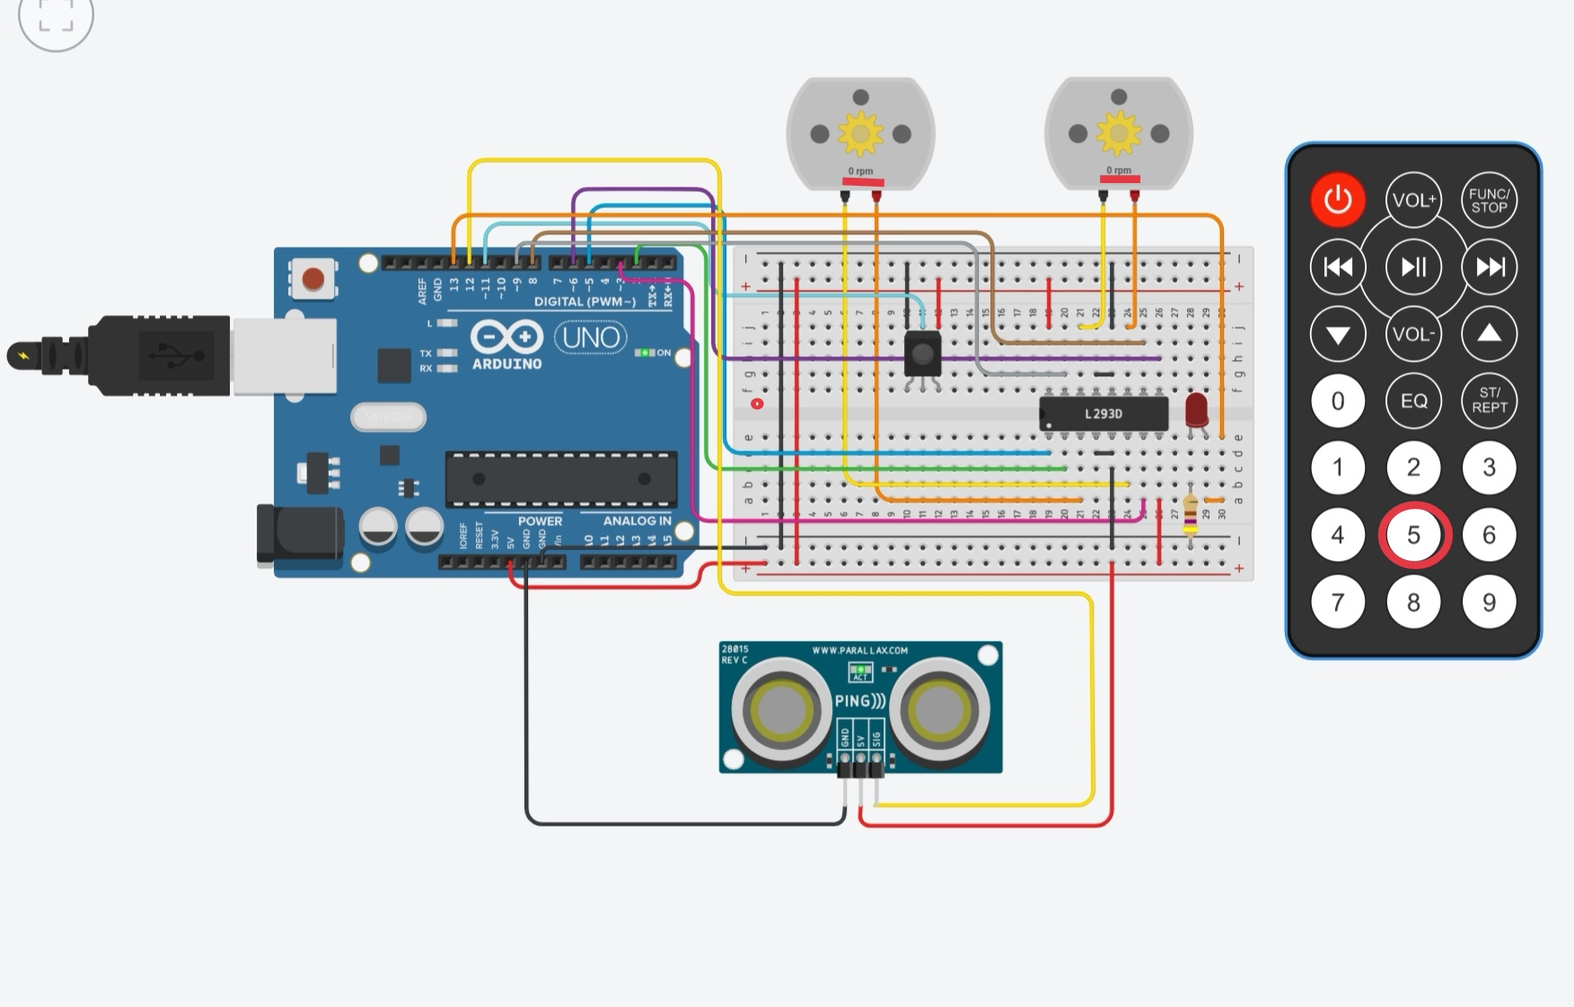
Figure 6-8: Using the remote control to the motors
As the figures above, when the '1' button is pressed, the motors spin at a high speed of 9,172 rpm; when '2' is pressed, the motors spin at a low speed of 3,611 rpm. '3' and '4' control the same way with only reversed direction. A '5' gives a brake signal.
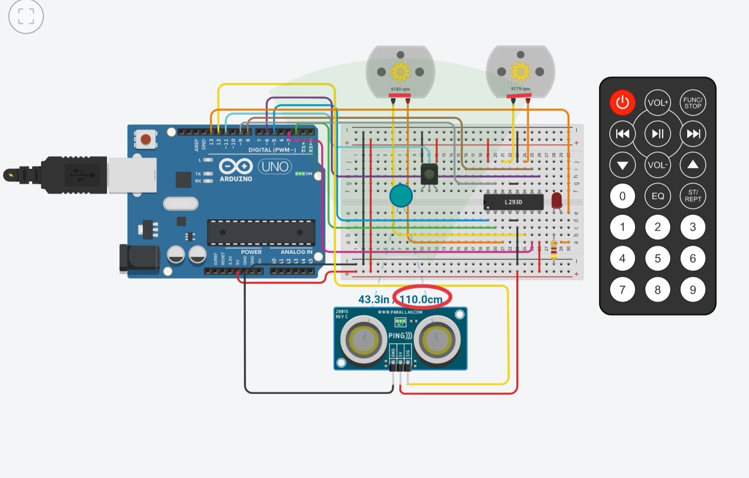
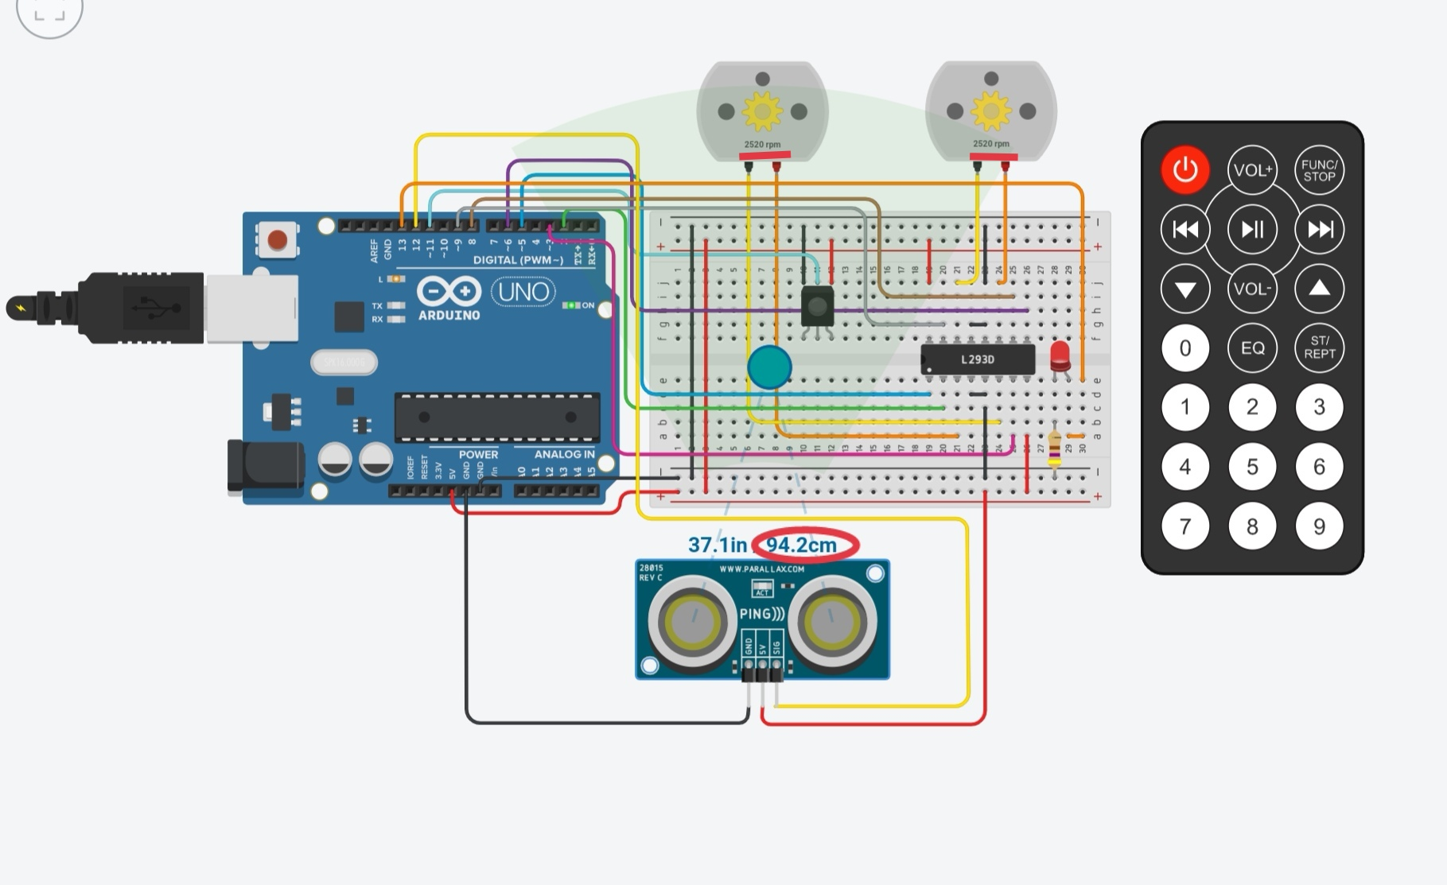
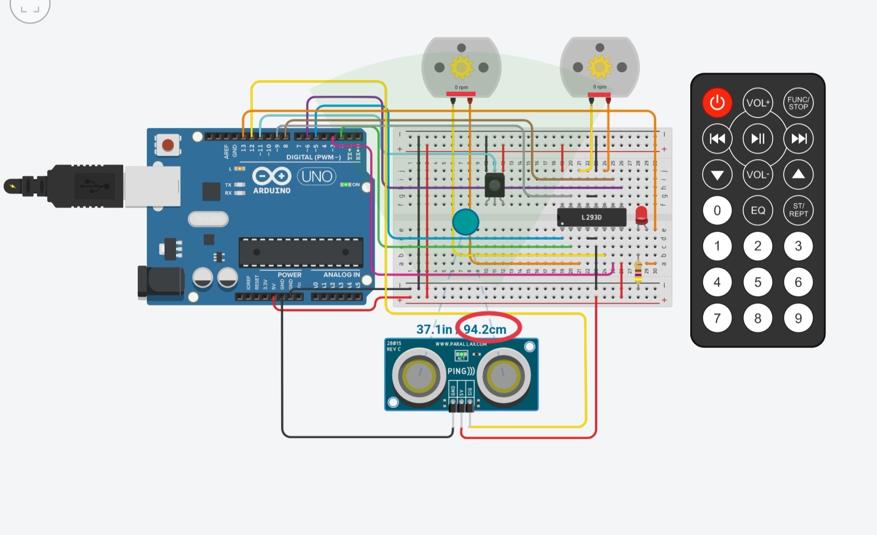
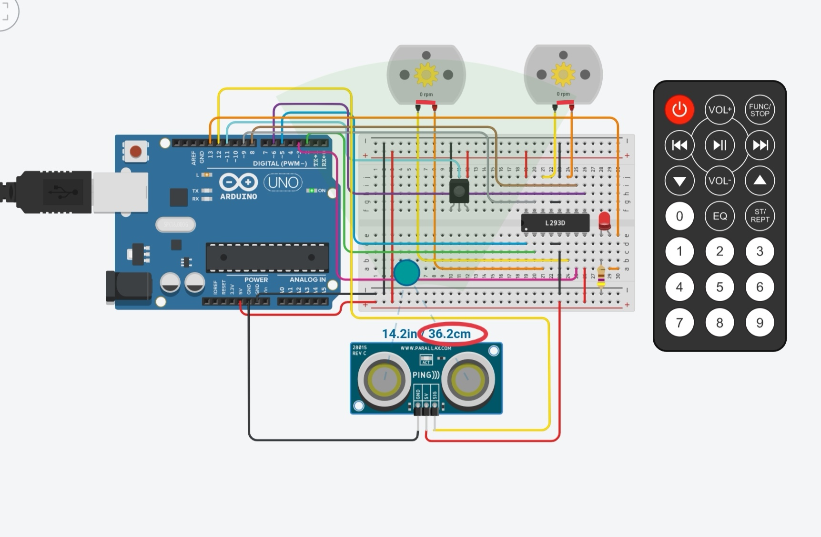

Figure 9-12 The ultrasonic sensor controlling the motors
As shown above, the motors keep spinning when the distance is over 100cm. When the object gets closer and is within the range of 50-100cm, the LED is lit up, and the motors slow down until a speed of 0. When a distance under 50cm is reached, whether immediately or gradually, the motors brake at once, and the LED is on.

3.Discussion about the experiment

3.1 The experiment error

3.1.1 Analysis of infrared remote control error
First of all, we use the hexadecimal code to realize the motor control operation by the infrared remote control fixed keys. The hexadecimal code is as follows:
Power | 0xFD00FF
1 | 0xFD08F7
2 | 0xFD8877
3 | 0xFD48B7
4 | 0xFD28D7
5 | 0xFDA857

Among them, button 1 represents fast forward; 2 means slow forward; 3 means fast reverse, and 4 means slow reverse; 5 is for braking.
During the experiment, we found that after each keystroke, it would take a period for the motor to perform the operation represented by the keystroke; that is, there was a delay between the key and the actual control motor. Since we did not set a delay procedure in the program, we consider that the system error caused the delay. The infrared remote control needs to transmit code to the motor to control the operation of the motor.

3.1.2 Error analysis of ultrasonic distance sensor
Because in the experiment, we need to detect the distance through the ultrasonic distance sensor to control deceleration and braking. However, we found that the ultrasonic distance sensor is not sensitive. It is not easy to measure the distance accurately.
According to the requirements, we need to slow down within the range of [50-100]. However, through our experiment, the ultrasonic distance sensor has already started to slow down when the distance is about 110. However, after our timely debugging, we corrected the error of deceleration, which is thus performed within 100cm.
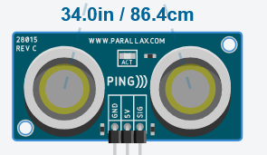
Figure 14: The distance is within the range of 50-100cm
According to the requirement, when the distance is less than 50, we need to make the car brake immediately. Actually, there is a delay. The speed will not decrease immediately.
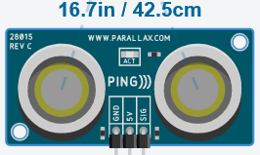
Figure 15: The distance is within the range of 0-50 cm
The above errors may be generated because it takes some time for the motor to operate when the ultrasonic distance sensor measures the distance. The transmission of information between the ultrasonic distance sensor and the motor is not directly executed. The ultrasonic sensor first needs to send signals to the UNO, which will analyze the signals and then send them to the L293D motor driver, and then the motor driver can control the motor.

3.2 Discussion of results
In our experiment process, we realized all the required operations, that is, through the infrared remote control keys to control the car fast forward, slow forward, fastback, slow back and brake. Although it takes a short time for the motor to operate after pressing the button, this delay period is very short after our debugging, which can achieve the purpose of the experiment. Through the ultrasonic distance sensor, we can also control the work of the motor through the measured distance. Although the ultrasonic sensor has some errors, the error is within the acceptable range after our debugging. Therefore, the experiment is successful.

4.Conclusion ▪

4.1 The hardware part

4.1.1 The H-bridge L239D
In the experiment, we use the L239D to control the motor forward, backward, stop. By setting different parameters, we can control the speed of forward and backward.

4.1.2 Infrared remote control
We controlled the motor through different buttons on the remote control. The numbers 1-5 represent fast forward, slow forward, fast backwards, slow backward, and braking, respectively.

4.1.3 Ultrasonic distance sensor
Through the ultrasonic distance sensor, we realized the motor running at different speeds at different distances. For example, in the range [50-100], the car will gradually slow down. At a distance of 50, the motor will stop working. After the experiment, we also carried out an error analysis, and the experiment was successful.

4.2 Software part
By defining the high and low-level input of four different Pins in different states, we realize the different motion states of the car. The 'void loop{}' function in each cycle firstly sets the LED off and then judge if a latest infrared signal is decoded by 1 or 0. If 1, the motors will perform the function defined by the buttons, and subsequently operate according to the distance read; if 0, the motors will directly operate according to the distance read by the ultrasonic sensor.

4.2.1 Infrared sensor part
In the loop function, we define 6 cases: POWER and keys 1, 2, 3, 4, and 5. Each of these numbers represents a state of the motor. One means fast forward, and two means slow forward, three means fast backwards, four means slow backward, and five means brake. We control the input high and low levels utilizing H-Bridge to control the state of the motor.

4.2.2 Ultrasonic distance sensor
First, we measure the distance which is from the Ultrasonic distance sensor. Through the appropriate formula calculation, when the distance is less than 100, the motor speed decreases. When the distance is less than 50, the motor stops working.

5.Author list and contributions ▪
No. | Name | Contribution  Description | Percentage（%） | S
1 | Zhuoyuan.Liu | Figured out how to measure the distance by applying an ultrasonic distance sensor. | 33.33
2 | Tiankuo.Jiao | Finished all the basic requirements, make the motor move freely. | 33.33
3 | Yuhang.Jiang | Wrote the programme to control the motor by using the IR remote. | 33.33

- Appendix

#include <IRremote.h> /*include the library used by the IR remote*/
IRrecv rc(11);
decode_results results;
const int PWM_M1 = 5; const int IN1_M1 = 2;
const int IN2_M1 = 3; const int PWM_M2 = 6;
const int IN1_M2 = 8; const int IN2_M2 = 9;
const int LED = 13;
int speed=100; int distance;
void setup(){ /*setup pin mode*/
Serial.begin(9600);
rc.enableIRIn();
pinMode(PWM_M1,OUTPUT); pinMode(PWM_M2,OUTPUT);
pinMode(IN1_M1,OUTPUT); pinMode(IN2_M1,OUTPUT);
pinMode(IN1_M2,OUTPUT); pinMode(IN2_M2,OUTPUT);
pinMode(LED, OUTPUT);
}
void loop(){ /*main function*/
digitalWrite(LED,LOW);
if (rc.decode(&results)){
switch(results.value){ /*identify which bottom is pressed on IR remote and switch to the corresponding function*/
case 0xFD00FF://power
break;
case 0xFD08F7://1
forward(250);
break;
case 0xFD8877://2
forward(100);
break;
case 0xFDA857://5 stop
stop();
break ;
case 0xFD48B7://3
backward(250);
break ;
case 0xFD28D7://4
backward(100);
break ;
}
rc.resume();
}
distance= 0.03446*readUltrasonicDistance(12,12);
Serial.println("distance");
Serial.println(distance);
if (distance>50&&distance<100){
digitalWrite(LED,HIGH);
speedDown();
if (distance<50){
stop();
}
delay(100);
}
else if (distance<50){
digitalWrite(LED,HIGH);
stop();
delay(600);
}
}
void forward(int speed){ /*the function to make the motor rotate forward*/
Serial.println("forward"); /*use a parameter passed in to control rotate speed*/
analogWrite(PWM_M1, speed); analogWrite(PWM_M2, speed);
digitalWrite(IN1_M1, HIGH); digitalWrite(IN2_M1, LOW);
digitalWrite(IN1_M2, HIGH); digitalWrite(IN2_M2, LOW);
}
void backward(int speed){ /*the function to make the motor rotate forward*/
Serial.println("backward"); /*use a parameter passed in to control rotate speed*/
analogWrite(PWM_M1, speed); analogWrite(PWM_M2, speed);
digitalWrite(IN1_M1, LOW); digitalWrite(IN2_M1, HIGH);
digitalWrite(IN1_M2, LOW); digitalWrite(IN2_M2, HIGH);
}
void speedDown(){ /*function make speed of rotation decrease gradually until 0*/
Serial.println("speedDown");
speed-=10;
if(speed<0) speed =0;
analogWrite(PWM_M1, speed); analogWrite(PWM_M2, speed);
}
void stop(){ /*function to stop the motor*/
Serial.println("stop");
digitalWrite(IN1_M1, LOW); digitalWrite(IN2_M1, LOW);
digitalWrite(IN1_M2, LOW); digitalWrite(IN2_M2, LOW);
}
/*an algorithm to calculate the distance to the forward object by the sonic signal’s travel time*/
long readUltrasonicDistance(int triggerPin, int echoPin)
{
pinMode(triggerPin, OUTPUT); // Clear the trigger
digitalWrite(triggerPin, LOW);
delayMicroseconds(2);
// Sets the trigger pin to HIGH state for 10 microseconds
digitalWrite(triggerPin, HIGH);
delayMicroseconds(10);
digitalWrite(triggerPin, LOW);
pinMode(echoPin, INPUT);
// Reads the echo pin, and returns the sound wave travel time in microseconds
return pulseIn(echoPin, HIGH);
}

- Reference
[1] Department of Electrical and Electronic Engineering, “Week 5 Smart Car & Sustainability 1”.[Online]. Available:https://learningmall.xjtlu.edu.cn/pluginfile.php/120099/mod_resource/content/1/Week5.pdf

